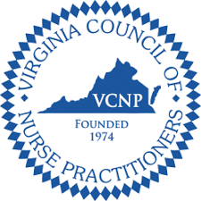
VCNP Piedmont Region Pharmfest 2023
Saturday, January 28, 2023
Omni Hotel Charlottesville
7am to 4:30pm

6 Pharmacology CE Credits provided

7:00-8:00 Registration and Breakfast

8:00-8:10 Opening Remarks
Renee Gay, DNP, AGACNP-BC, VCNP Piedmont President

8:10-9:10 Sleep/Wake Pharmacology (CE: 1.0)
Ellen Wermter, FNP, DBSM

9:10-10:15 Major Depression and Crisis Management (CE: 1.0)
L. Kelley Midkiff, NP, CNS

10:15-10:45 Break & Visit Exhibitors

10:45-11:50 Vaccination Updates (CE: 1.0)
Donna White, RPh; Lauren Lam, PharmD; Stephanie Hannon, PharmD

11:50- 12:50 Lunch Break

12:50-1:55 Not All that Shakes is Parkinson’s (CE: 1.0)
Debbie Lindsay, MS APRN, ACNP

1:55-3:00 Updates in Dermatology Pharmacology (CE: 1.0)
Rachel Talbott, FNP, DNP

3:00-3:20 Break & Visit Exhibitors

3:20-4:25 Heart Failure (CE: 1.0)
Elizabeth Lester, DNP, AGACNP-BC

4:25-4:30 Closing remarks and time to complete evaluations

