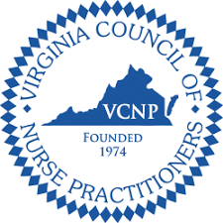
VCNP Piedmont Region Pharmfest 2022
Virtual Pharmacology Conference
January 29, 2022
8am to 3:30pm

8:00-8:05 Opening Remarks
Katy Morgan, CPNP-AC, VCNP Piedmont President

8:05-9:00 Care of the Diabetic Patient with Comorbidities Across the Continuum (CE: 1.0)
Debra Levin RNC, MSN, NP-C, BC-ADM

9:00-10:00 Pharmacologic Management of Atrial Fibrillation (CE: 1.0)
Mahesh Murugesan, RN, MSN, PhD

10:00-10:15 Break

10:15-11:45 Medication Assisted Therapy in Treatment of Opioid Use Disorder, A Team Approach (CE: 1.5)
Kelly Schorling, MSW, LCSW and Jeffrey Katra, MD

11:45- 12:30 Lunch Break

12:30-2:00 COVID- 19 Therapy Update (CE: 1.5)
Patrick Jackson, MD

2:00-2:15 Break

2:15-3:15 Pharm-to-Table: Understanding the Different Flavors of Cannabis in Medicine – Let’s Weed Through the Updates! (CE: 1.0)
Andy Whitman, Pharm-D

3:15-3:30 Closing remarks and time to complete evaluations

