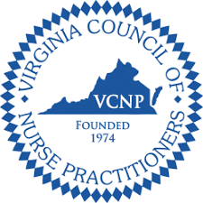
VCNP Piedmont Region PharmFest 2021
Virtual Pharmacology Conference
January 30, 2021

8:00 am to 8:15 am Opening Remarks by Katy Morgan, President
8:15 am to 9:15 am Menopausal Syndrome and Pharmocological
Therapies – Dr. Carolyn Wilson (1.0 CE)
9:15 am to 9:30 am Break
9:30 am to 10:30 am Weight Loss: Pharmacological Therapies –
Donna White, BS Pharm, CDDES, BCACP (1.0 CE)
10:30 am to 10:45 am Break
10:45 am to 11:45 am ADHD Medications and Guidelines for
Therapy – Lauren Pohl, PharmD (1.0 CE)
11:45 am to 1:00 pm Lunch Break
1:00 pm to 2:30 pm Pearls When Prescribing Contraceptives:
Review & Update – Caitlin Lugo, FNP-C &
Stacey Seeley, MSN, APRN, WHNP-C (1.5 CE)
2:30 pm to 2:45 pm Break
2:45 pm to 3:45 pm Chronic Cough: A Case Study on Neurogenic
Cough – Amy Culbertson, DNP, FNP-BC (1.0 CE)
3:45 pm to 4:00 pm Break
4:00 pm to 5:00 pm COVID 19 Update – Dr. Patrick Jackson (1.0 CE)
5:00 pm to 5:15 pm Closing Remarks and time to complete evaluations

